Whats the event?
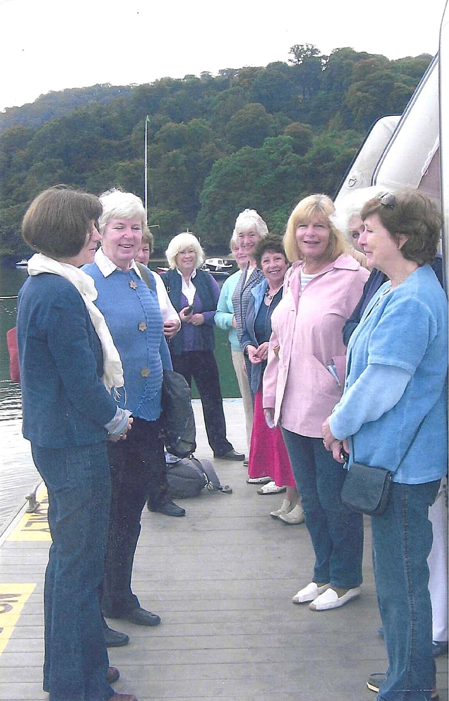

Popes Quay(?)
L to R
Cathy Matthews, Kate Lawley, Marilyn Sherlock, Mary.(can’t remember surname) Jeanne Venning, Nicky McDougall, Pam Carter, Carol Williams, & Jane Barnett

