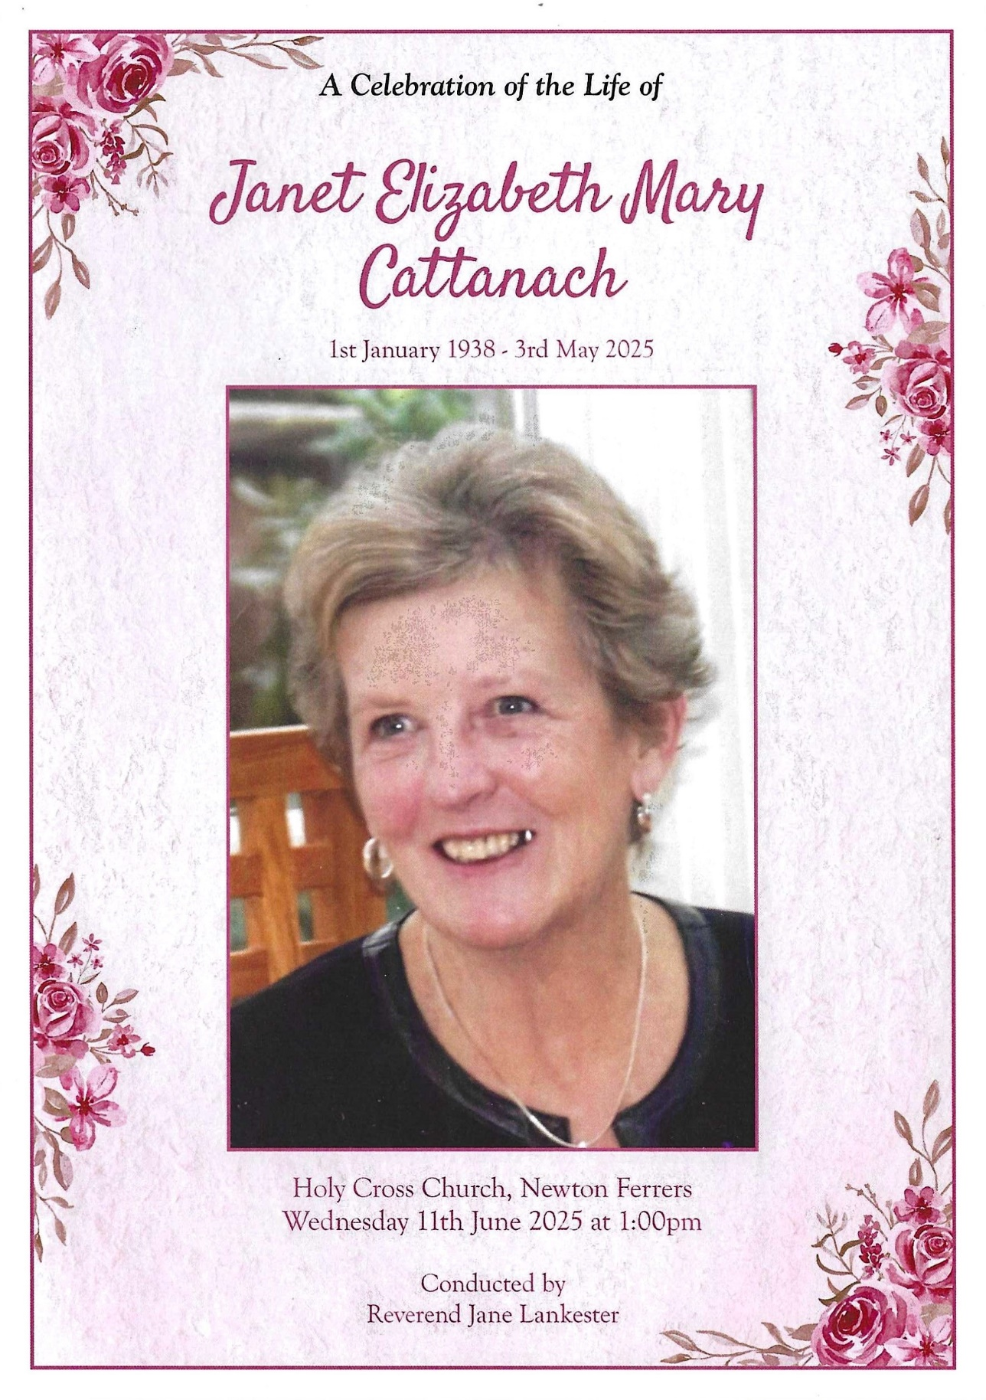
Janet was a much loved and talented lady. She held most roles within the WI, and was always willing to help out, throwing herself into theatre productions, book club, the choir and craft. Janet was very skilled at flower arranging, and always did the WI flowers for the Holy Cross flower festival. Words cannot describe how much Janet will be missed.
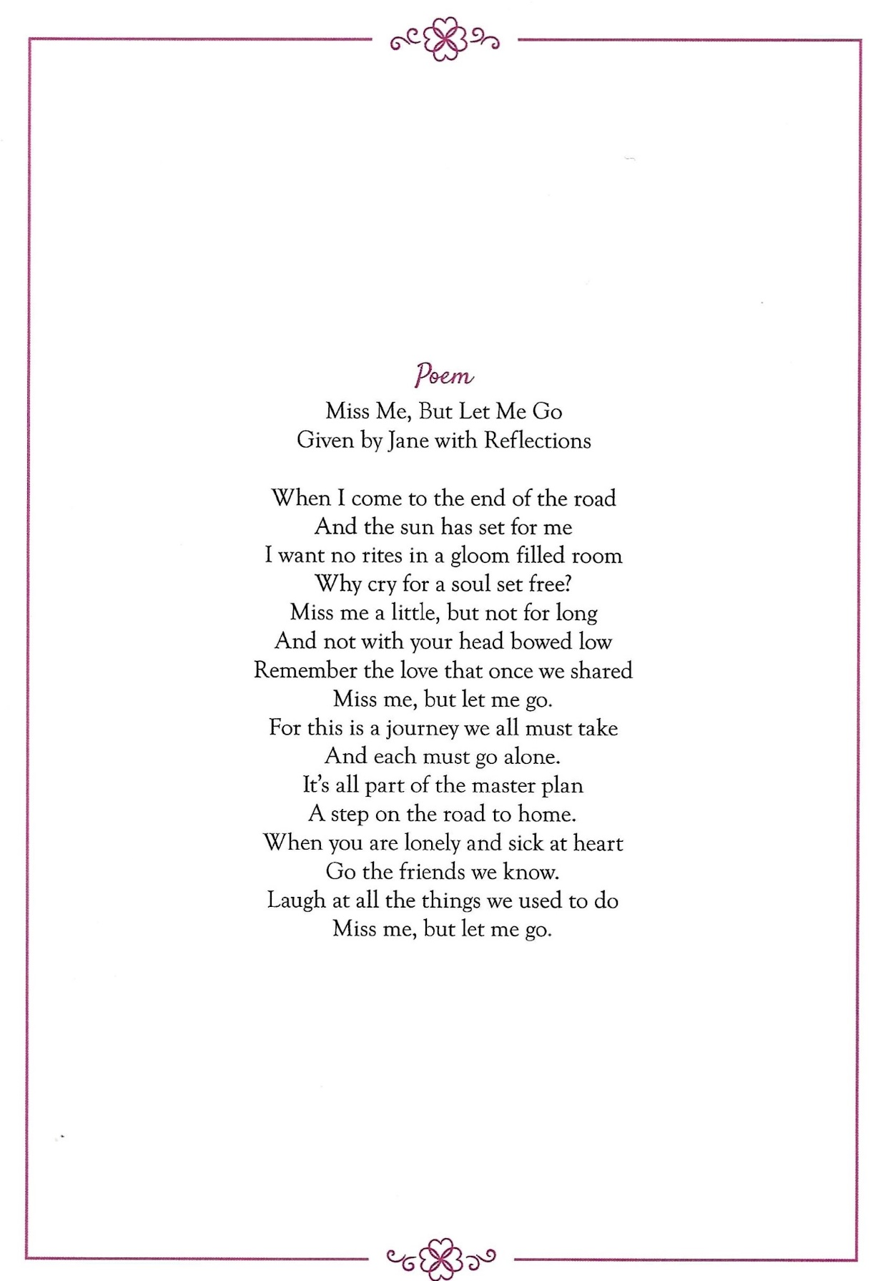
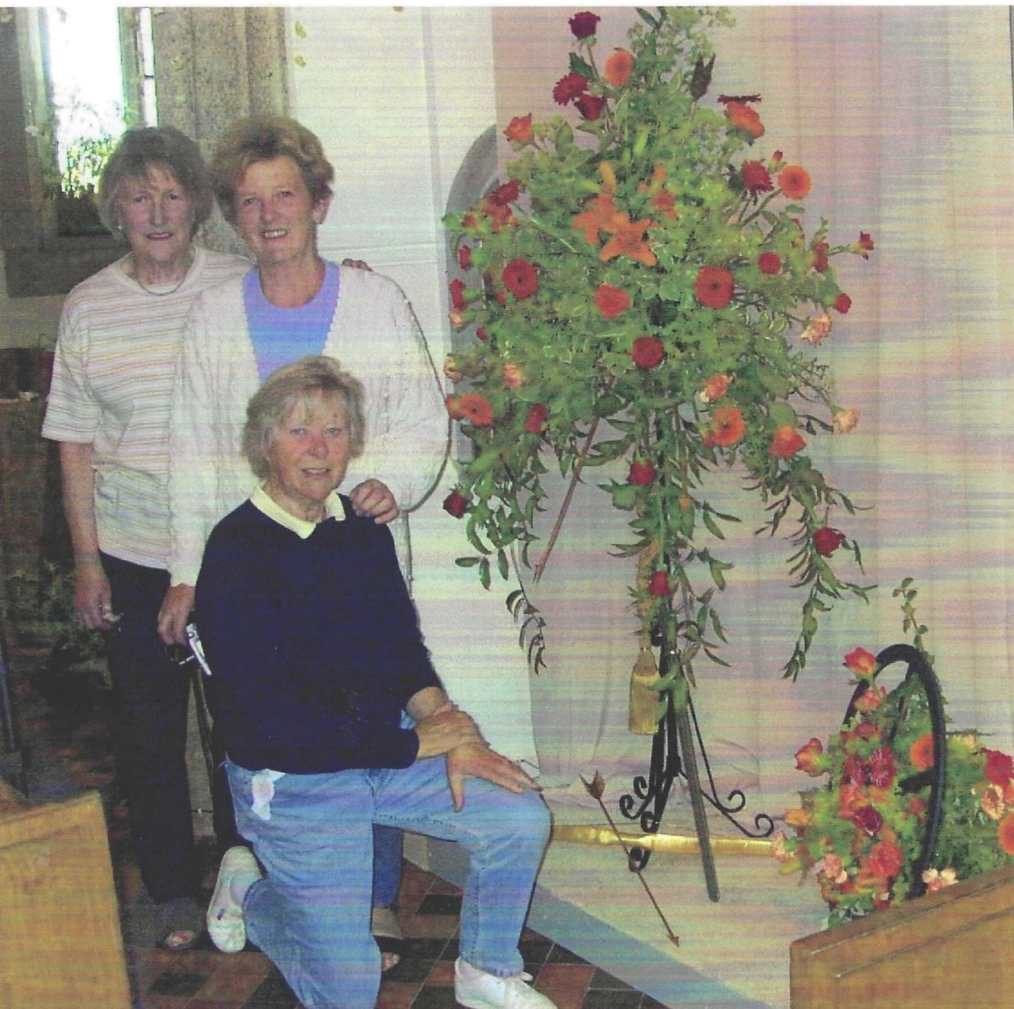
Church flowers with Leslie Davenport (kneeling)and Betty Christie

