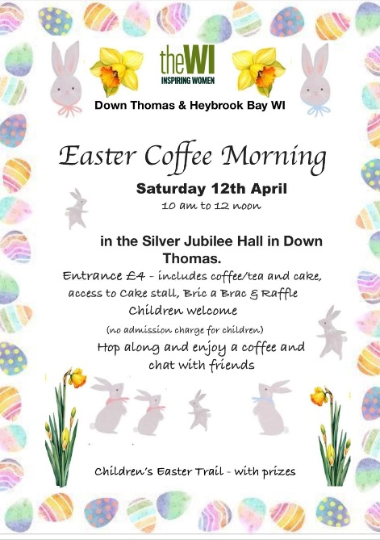
Jackie Ross & Lesley Dempsey went to Down Thomas village hall to attend the Down Thomas & Heybrook Bay WI Easter coffee morning.

We were very impressed with the welcome we received.
The array of cakes for sale was amazing.
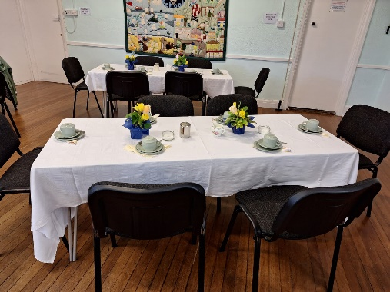
Jackie found a book on the bric-a-brac table, and a bird feeder.
We were both delighted to find we had won prises in the raffle. (Lesley’s was a bottle of wine & Jackie’s some toiletries).
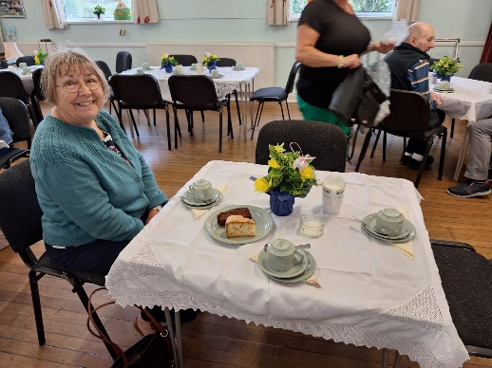
We were waited on at our table after choosing our cake – a slice of apple cake (Mary Berry’s recipe but gf) and chocolate cake. They were yummy. Coffee came in a cafetiere, and tea in a pot.
The tables were beautifully decorated with spring flowers and decorated eggs.

