MARY THOMAS’S 100th BIRTHDAY on 28th MARCH
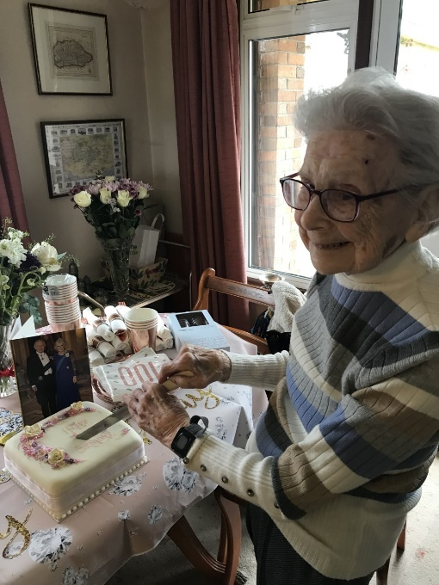
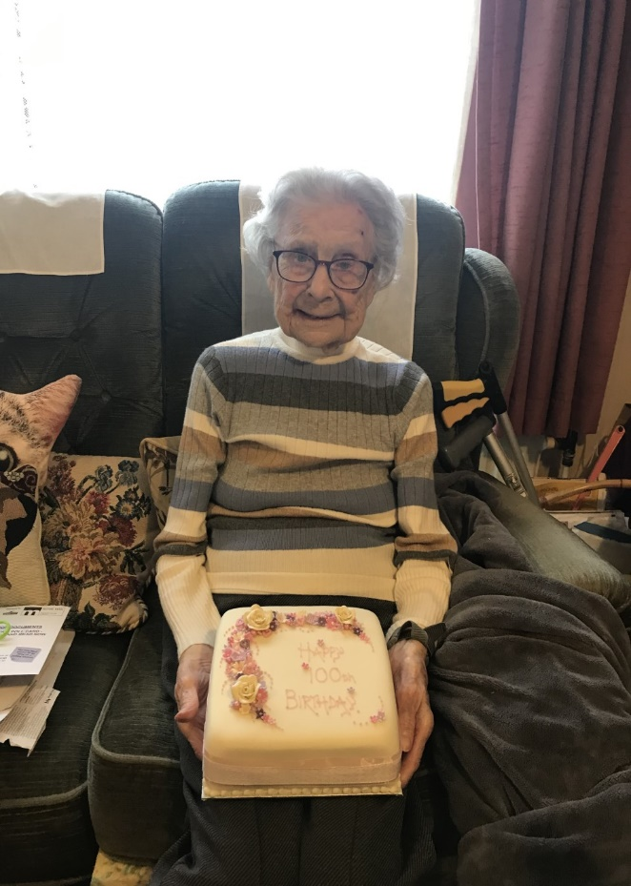
When we took the card and a little pot of primroses from our WI round to Mary on the morning of her 100th birthday, we found her surrounded by cards and flowers. It looked like moonpig meets Kew Gardens! It was clear as she took phone calls, one of them from Australia, that a lot of people wanted to share the celebration with Mary. Shirley had ordered a special cake and hung balloons inside and outside the house and we sang Happy Birthday on the WI members’ behalf – what we lacked in melody, we made up for in volume!

Mary was born in Rushden in Northamptonshire but left home at 18 to join the ATS. When she got married to Tommy in 1962 his work brought him to the West Country and they set up home in Newton Ferrers. Mary worked for about 15 years as secretary to the Senior Partner at Bond Pearce (now Womble, Bond, Dickinson) at their offices which were then at No.1 The Crescent in Plymouth.
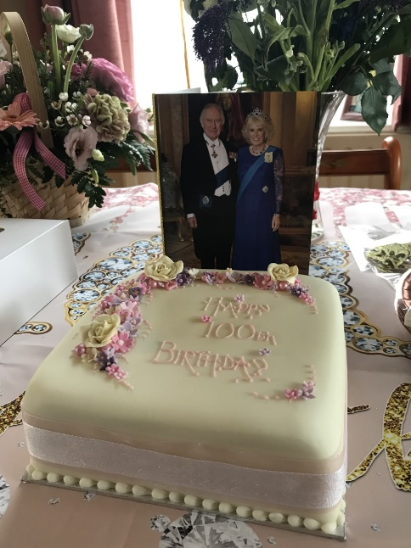
She joined the WI in the 1980s and when the hall was reopened in 2014 after the refurbishment Mary, as our oldest member, was invited to take part in the ceremony. She still holds the distinction of being our oldest member, so…
Many Happy Returns Mary!

