2002 Presentation to Paddy Scammell
On her retirement from organising the Craft group

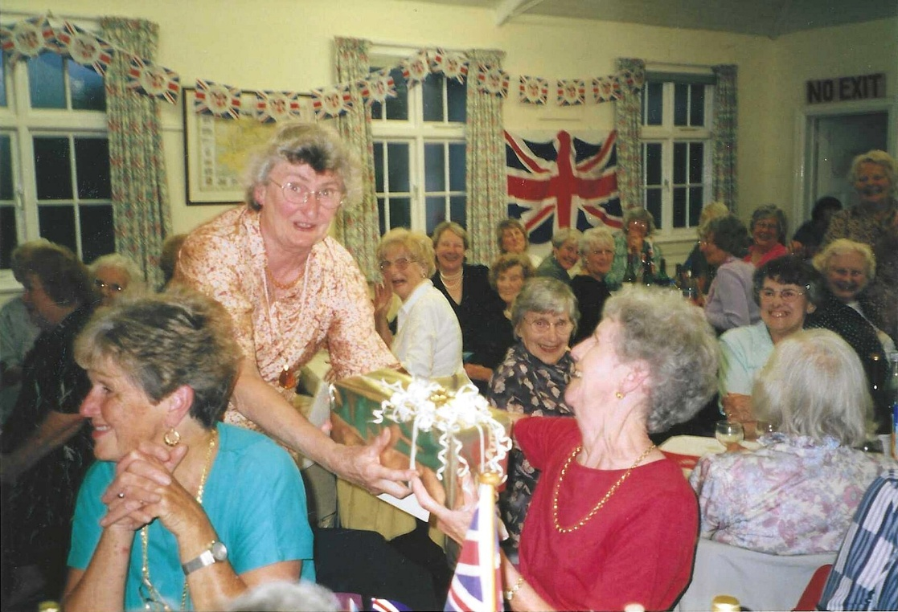
Rosemary Watts presenting Paddy Scammell with a gift
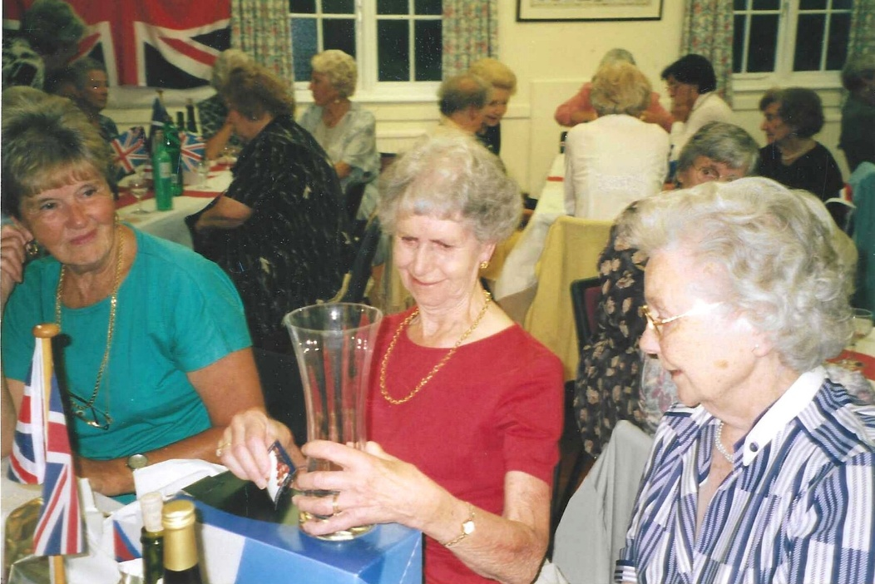

Paddy Scammell centre
Mary Thomas Right
Margot Preece. Left

