Newton Ferrers and Noss Mayo WI

Trauma Teddies

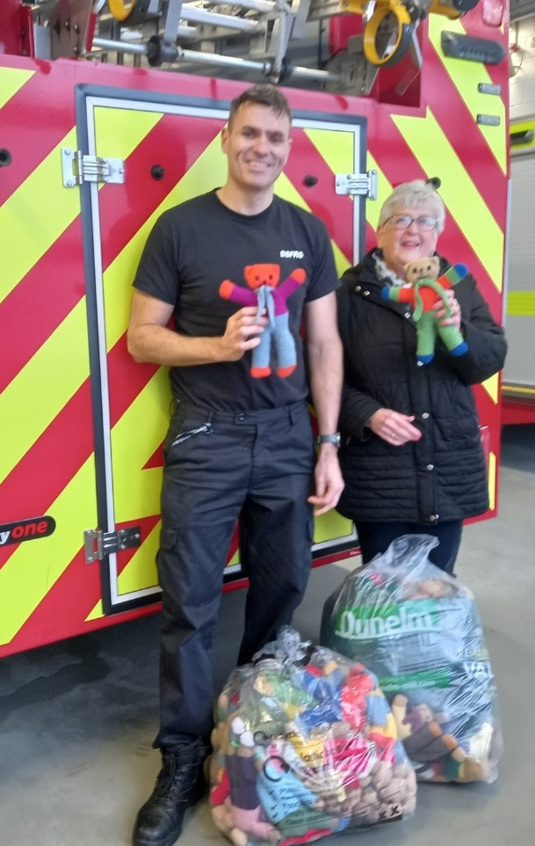
The Craft Group mainly Jackie Ross, Nikki McDougal, Cathy Matthews, Joan Miller & Gill Tune, have been busy knitting a whopping 132 trauma teddies
These were delivered to Greenbank fire station on 22nd December for distribution.

